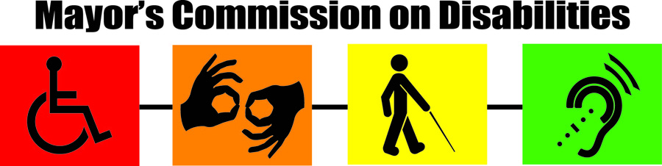

Web address: http://mcd.baltimorecity.gov

Resources
ACCESSIBILITY
MD Relay, Communication Services | 711 (TTY users)
The Hearing & Speech Agency | 410-318-6780
Childhood Speech and Language Center | 410-243-3800
ADVOCACY
Baltimore Neighborhoods, Inc. (Federal Housing) | 410-243-4400
Baltimore Neighborhoods, Inc. (Tenants/Landlords) | 410-243-6007
Office of Civil Rights | 410-396-3141
Parents' Place of Baltimore | 410-859-5300
Families Involved Together | 410-235-5222
IMAGE Center for Independent Living | 443-377-3472
CHILDREN'S SERVICES
Developmental Disabilities Administration Central MD Regional Office | 410-234-8200
MD Infants & Toddlers Program | 410-767-0261
School Health | 410-396-3185
ACCESSIBLE PARKING
Reserved Residential Parking (Baltimore City) | 443-573-2800
Tags and Parking Permits-MVA (Maryland) | 800-950-1682
EDUCATION
Baltimore City Public School System (City Schools Connect) | 410-396-8700
EMPLOYMENT & JOB SKILL DEVELOPMENT
Employment & Training Division, Labor Licensing and Regulation | 410-767-2000
Office of Employment Development | 410-396-3009
EQUIPMENT
MD Technology Assistance Program | 1-866-881-7488
National Federation of the Blind | 410-659-9314
The Workforce & Technology Center | 410-554-9385
Maryland Relay | 711
HOUSING
Housing & Community Development | 410-396-5000
Housing Authority of Baltimore City 410-396-3237
LEGAL SERVICES
Maryland Disability Law Center | 410-727-6352
LIBRARY SERVICES
Enoch Pratt Free Library – Central Library | 410-396-5430
State Library For The Blind And Physically Handicapped | 410-230-2424
MEDICAL AND HEALTH CARE
Baltimore City Health Department | 410-396-4398
Behavioral Health Systems | 410-837-2647
RECREATION
Recreation & Parks | 410-396-7900
REHABILITATION
League for People with Disabilities | 410-323-0500
Division of Rehabilitation Services (DORS) | 410-554-9442
SOCIAL SERVICES
Department of Social Services | 443-378-4600
Resource and Support | 443-423-4000
Adult Services | 443-423-6612
Homeless Services | 410-396-3757
U.S. Social Security Administration | 1-800-772-1213
Child Protective Services | 410-361-2235
TRANSPORTATION
Mass Transit Administration-Information Line | 410-539-5000
Mobility | 410-764-8181

